Reshma Giji
r.giji@master.unisg.it
University of Gastronomic Sciences
Global Food History
28/01/2025

Feasts of Faith: How the Bible Shapes Culinary Traditions, Ethics, and Global Cuisine
Seen as just a religious book, the Bible could provide more to our history textbooks than we ought to let on. Through the plowing of modern archeology, we can see that the bible can show us historically accurate events dating back to the 16 century BCE. For instance, the discovery of the artifacts relating to King David was uncovered in 1994, in Northern Galilee where a stone slab with inscriptions of King David and the "House of David," was written. Or the unearthing of the evidence that a group of people called the Hittites ever existed. Mentioned more than 40 times in the Bible, the Hittites are recorded as an Empire that ruled the area of Syria and eastern Turkey and battled with Egypt and Babylon for territory. And in 1906 Hugo Winckler, a German archeologist, discovered the capital city of this ancient Empire and their entire library as well as 10,000 clay tablets documenting the Hittite history. Last but not least, the Dead Sea Scrolls which contained every book in the Old Testament (except Esther), were found in eleven caves near Khirbet Qumran, on the northwestern shores of the Dead Sea. Upon the staggering pieces of evidence of the Old Testament, the Smithsonian Institution’s Department of Anthropology put forth the statement, “The historical books of the Old Testament are as accurate historical documents as any that we have from antiquity and are in fact more accurate than many of the Egyptian, Mesopotamian, or Greek histories. These Biblical records can be and are used as are other ancient documents in archaeological work.” Using the Bible as a historical cookbook, we can gain creative insight to explore ancient culinary practices, cultural traditions, and most importantly the significance of food in religious and social contexts.
Establishing the validity of the bible, we can dive into the texts that provide us with what meals and ingredients looked like from 16th BC. One of the first meals we see read is in the book of Genesis 18:6-8, “And Abraham hastened into the tent unto Sarah, and said, make ready quickly three measures of fine meal, knead it, and make cakes upon the hearth. And Abraham ran unto the herd, and fetcht a calf tender and good, and gave it unto a young man; and he hasted to dress it. And he took butter, and milk, and the calf which he had dressed, and set it before them; and he stood by them under the tree, and they did eat.” We read one of the oldest recipes of bread, tender beef and we see the introduction of butter. This event is of key importance to unraveling the culture of the food and its interaction with humans. We can even consider this a small feast. A couple of verses before this, we find out that these were but just three strangers who stumbled upon Abraham’s tent, and instead of sending them away, Abraham pleads that they stay over for a meal. It is also important to note that during these times, the kitchen and food preparation were traditionally women’s domains, especially in ancient Israelite and early Christian societies. Looking into the book of Proverbs chapter 31:15-27 we read, “She gets up while it is still night; she provides food for her family and portions for her female servants… She watches over the affairs of her household and does not eat the bread of idleness,” and many of the women in the Bible (e.g., Sarah, Rebekah, Mary) are depicted in the context of home and hospitality, which includes food preparation. The history of this meal is marked with an equal importance of hospitality and humility. And it is still quite evident that people from the Middle East and Africa often mix food and hospitality in the same bowl. Another reason for calling this a feast is the butchering of a tender calf, which is usually reserved for special occasions and is considered a treat. I got a chance to prepare the bread, but with limited recipe information, I was able to find a website called the Bible Cookbook. I started using the measurement of flour (three measures / a little over a bushel of flour) from the bible only to realize that would come over to around 150 cups of flour. So, I stuck with just ½ a cup of flour along with a little salt and some hot water, only to knead it like a dough. I partly cooked it on the stove and then transferred it on top of hot medium sized stone. While the bread was a little too hard for my liking, but I did enjoy it with some salted butter.
Another significant feast is the Passover meal; which is also known as the Sedar is a symbolic meal to commemorates the Israelites' liberation from slavery in Egypt, as described in the Book of Exodus 12: 8-13, “That same night they are to eat the meat roasted over the fire, along with bitter herbs, and bread made without yeast. Do not eat the meat raw or boiled in water, but roast it over a fire—with the head, legs and internal organs.” This is to be practiced every year on the Hebrew calendar dates of Nissan 15-22. According to the scriptures, the lamb is to be roasted over fire and eaten with a salad of bitter herbs and unleavened bread. But today many Jews choose to buy pre-packaged matzah. Industrialization has either helped or lost the preparation of the Passover meal. Many supermarket stores sell soups, gravies, and sauces, prepared with Passover restrictions for Jews. I have also heard of companies that sell ready-to-serve dishes such as brisket, chicken, and potato kugel, that only need to be reheated. The growth of industrialization has brought a significant challenge in the Passover meal. Because of its ritual with specific rules and customs, it can be difficult to replicate this on an industrial scale. And this industrialization of meals can be seen as stripping away the personal connection to the holiday. In this same context it is important to know how the Passover meal changes as Jews migrate to different parts of the world and how they have adopted the foods of the country they have lived in but have a twist of their taste and smell embedded. For example, Jews in India celebrate the Passover with a couple of rolls of chappatis, a South Indian bread made without yeast and can be prepared in 30 minutes. Or in Ethiopia, where Jews would sometimes make a variation of matzos using chickpeas and would mark the end of the eight-day bread-free holiday by eating kategna. As mentioned before, within the Jewish diaspora, the foods served during the Passover meal often reflect the local agricultural products and culinary traditions.
When we arrive at the New Testament, Jesus rebuts the devil (the accuser in its most literal translation) in Matthew 4:4 quoting this profound statement, "Man shall not live by bread alone, but by every Word that proceeds from the mouth of God." Jesus Christ is no stranger to food, sustenance, or celebration - His first miracle was turning water into wine that exceeded the vintner's aptitude! But the sharp contrast He provides to the devil's temptation sets the following foundation for humans everywhere to choose. The same Man who turns water into wine denies its numbing properties at the Cross. At the seder meal, He says that He won't drink wine till He is in glory with us who are faithful. Christ denies this pleasure because He knows that the fullest expression of wine is not in its flavor or culture, but is found with those who enjoy Him more than bread alone. The ordinances of food extend far beyond the boundaries of flavor, sustenance, cultures, and recipes. Its most holistic expression can only be found in the One who sowed it for man to reap and enjoy. For outside of God, the interpretation of food has some meaning but is always found wanting. And no amount of study or taste can satisfy intellectually, logically, or emotionally. This is why Christ says that man cannot live by bread alone, but the Word of God fills the infinite chasm found in the finite human. Christ drives home this point in His parable of the wedding banquet found in Matthew 22. Here, He invites anyone who will simply believe what He teaches and does to the wedding banquet at the end. There are two highlights to any wedding - the wedding itself, and the meal. In view of Christ, this meal is accessible to anyone who simply puts their trust in Him. In other words, they get to partake of His meal if they pronounce their vows to Him in both death and resurrection. A foreshadow of this is the Communion table found in churches across the world. They celebrate this event, eagerly looking forward to their communion with Christ up above. And Christ looks forward to this eagerly too.
A question worth asking is how the acceptance of pork or in fact any animal that has a hoof comes into the Bible. We read in the book of Leviticus11: 7-9, “Nevertheless these shall ye not eat of them that chew the cud, or of them that divide the hoof… Of their flesh shall ye not eat, and their carcase shall ye not touch; they are unclean to you.” Seen as unclean animals, the Jews are required to separate and not indulge them. But we see a theological shift in the New Testament that has opened the doors of eating pork. Mark 7:18-19: Jesus says, "Are you so dull? Don’t you see that nothing that enters a person from the outside can defile them? For it doesn’t go into their heart but into their stomach, and then out of the body." Many Christians see this as an indication of a move away from Jewish dietary restrictions. Reading also Acts 10:9-16: In a vision, the apostle Peter is shown a sheet with all kinds of animals, including unclean ones like pigs, and is told by God, "Do not call anything impure that God has made clean." With this, many take it as a command from God that animals in kosher dietary laws mentioned in the Old Testament are no longer considered unclean. This helped when the gospel was beginning to spread to Asia, Africa, and even Europe and many foods that were considered unlawful to eat are no longer being restricted. And we see this within Easter meals that are celebrated all over the world. From the use of pork in the Polish White Borscht Soup or shrimp in the Ayam Cincalok. Such delicacies with shellfish, camel, and hare are eaten by Christians around the world.
Today we study the intersection of ethics and food production, particularly in movements like organic farming, food justice, and sustainability. A lot of these principles are rooted in biblical teachings regarding justice, and stewardship of the earth. Starting from the book of Genesis 1, “And God said, Let us make man in our image, after our likeness: and let them have dominion over the fish of the sea, and over the fowl of the air, and over the cattle, and over all the earth, and over every creeping thing that creepeth upon the earth,” and Genesis 2 “And the Lord God took the man, and put him into the garden of Eden to dress it and to keep it.” Humans are responsible for taking care of the earth ensuring the sustainability of the earth’s resources, and fostering a relationship of respect for the natural world. We can also see the gleaning law in Leviticus 19: 9-10, “And when ye reap the harvest of your land, thou shalt not wholly reap the corners of thy field, neither shalt thou gather the gleanings of thy harvest. And thou shalt not glean thy vineyard, neither shalt thou gather every grape of thy vineyard; thou shalt leave them for the poor and stranger: I am the Lord your God.” According to the law, it was commanded that farmers do not harvest their fields to the edges, leaving the edges of their fields and any forgotten crops for the poor and foreigners. We read another commandment in Leviticus 19:13, “thou shalt not defraud thy neighbour, neither rob him: the wages of him that is hired shall not abide with thee all night until the morning,” Today we talk about the exploitation of workers in coffee fields and coastal shores in Southeast Asia or the working of migrants in agriculture who may face poor working conditions, low wages, and lack of rights. But all over the Bible, there are verses that talk about the prophetic call for justice for the oppressed, the poor, and the marginalized, as well as warnings for those who do not heed it.
In exploring the Bible as a historic cookbook, we are able to uncover more than just ancient recipes or culinary practices. We are also able to dive into the cultural, social, and ethical dimensions of food throughout history. The Old Testament teachings press on food justice, and stewardship for ethical food production, sustainability, and fair treatment of workers. We can learn a lot from ancient wisdom to produce a sustainable and practical approach to food systems. As we continue to navigate these topics, I implore one to look at the Bible as it offers a powerful reminder of the moral responsibility, we bear not only to our communities but also to the Earth itself. Through the practice of these teachings, we can approach food with an understanding of its role in sustaining our body while also fostering a healthy earth that has been created for us. The beauty and taste of food lie in the eye of the beholder, for the beholder lies in the eye of God who preserves him to enjoy the works of His hand.

Bibliography
Whitten, Russ. “Have You Wondered: Is the Bible Historically Accurate?” The Destin Log, June 15, 2017. https://eu.thedestinlog.com/story/lifestyle/faith/2017/06/15/have-you-wondered-is-bible-historically-accurate/985681007.
GotQuestions.org. “Home.” GotQuestions.org, July 2, 2012. https://www.gotquestions.org/Hittites.html.
Imj.org.il. Accessed January 27, 2025. https://www.imj.org.il/en/wings/shrine-book/dead-sea-scrolls.
The Holy Bible Containing the Old and New Testaments, Authorised King James Version, (Cambridge: Cambridge University Press, 1984)
Tom. “Veal, a Delicate Delight in the Culinary World.” The Marinis Group, August 12, 2024. https://marinisgroup.com/veal-a-delicate-delight-in-the-culinary-world/.
Isaac, Ido. “The Celebration of Passover.” Home. Accessed January 27, 2025. http://indianjews.org/en/articles-en/116-the-celebration-of-passover.
“Saturday, February 1, 2014, 7:10 Am.” Ethiopian Food ♦ Mesob Across America. Accessed January 27, 2025. https://ethiopianfood.wordpress.com/2014/02/01/.
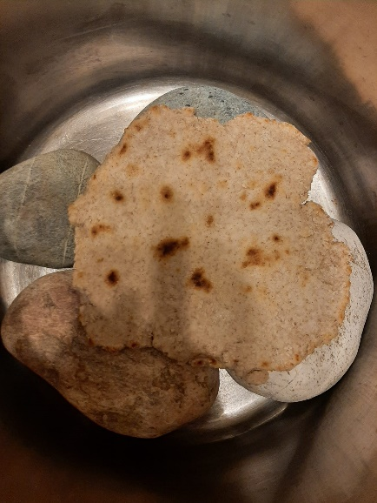
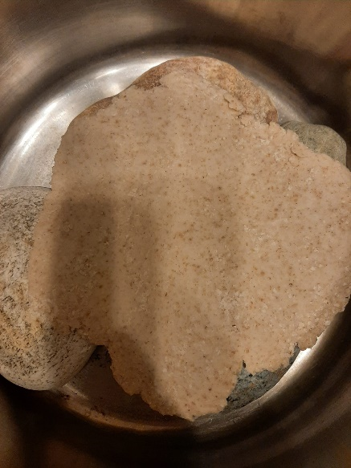


Russ Whitten, “Have You Wondered: Is the Bible Historically Accurate?” The Destin Log, June 15, 2017
GotQuestions.org, “Home,” GotQuestions.org, July 2, 2012
Imj.org.il, accessed January 27, 2025
Genesis 18:6-8 (Authorized (King James) Version)
Proverbs 31: 15-27 (Authorized (King James) Version)
Tom, “Veal, a Delicate Delight in the Culinary World,” The Marinis Group, August 12, 2024
Exodus 12: 8-13 (Authorized (King James) Version)
Ido Isaac, “The Celebration of Passover,” Home, accessed January 27, 2025
“Saturday, February 1, 2014, 7:10 Am,” Ethiopian Food ♦ Mesob Across America, accessed January 27, 2025
Mathew 4:4 (Authorized (King James) Version)
Leviticus11: 7-9 (Authorized (King James) Version)
Mark 7:18-19 (Authorized (King James) Version)
Acts 10:9-16 (Authorized (King James) Version)
Genesis 1:26 (Authorized (King James) Version)
Genesis 2:15 (Authorized (King James) Version)
Leviticus19: 9-10 (Authorized (King James) Version)
Leviticus19:13 (Authorized (King James) Version)

